Jack, born in 1961, has a terrible memory these days. It’s never been good - He was an alcoholic for some years, though not for a long time. But he retains in those old grey cells, a kind of disjointed dream of growing up in the 1960s, in Petts Wood near Orpington, Kent.

Jack used to watch Top of the Pops on TV with ‘Nan’ his maternal grandmother, who ‘minded’ him for half the week in her home at Lee Green near Lewisham, while his Mum Rosemary went out teaching at a variety of rough schools. Nan liked Peter Noone, whom everyone called ‘Herman’ after his band the Hermits, though Jack thought he was more like Herman Munster ! His parents’ Radio Rentals monochrome TV likewise had to be tuned in every time, no push-buttons or remote controls – however they rarely needed to do this as it was permanently on BBC 1. Jack’s mother was a snob and wouldn’t let her husband and only son watch ITV or “the other side”; this was deemed not quite proper.

Jack would water the concrete as much as the flowers with a toy plastic can, to watch the water rivulets dance down the gullies. He’d cut the worms in two and eat earth, and he’d drive his yellow pedal car everywhere – it had real battery lights on the front ! Of course, the batteries leaked, the yellow metal got rusty so the lights usually didn’t work, but somehow he never seemed to be out of place pedalling along in his frayed-fringed cowboy outfit and firing caps from his Milky Bar Kid style pistol ! Later he’d ride an (all-British) Mini Moulton bike, coming off it regularly and once losing it - which required a trip to the local Police Station to pick it up, for in those days everywhere still had one.

Jack’s Dad Geoffrey bought him the ‘Beano’, ‘Dandy’ or ‘Topper’ comic every week from the local newsagent opposite Western Approach, upon whose external wall hung an exciting machine. Here, for one old penny; chewing gum could be released; and best of all, one sometimes got a free packet every fourth turn of its knob! Most weeks they’d go to the new Library in Frankswood Avenue, since Jack had a reading age far ahead of his physical years. “Billy” Bunter books were his favourite, or other historical novels often about the kind of posh private schools that he would never be able to attend, populated by pupils who even by the 1960s would have been in their dotage, had they ever existed at all.

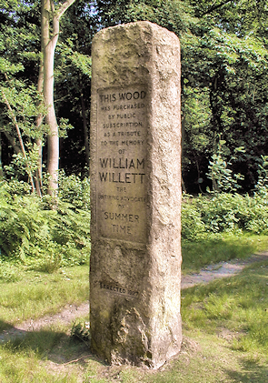
The long summer holidays from school never seemed to end. When they did, Jack would resume his short-trousered stalking of the distant tall red-headed girl Rosina as she walked arm-in-arm with her best friend the mile to Crofton Infants School. Of course being of single-digit age he did not talk to girls, nor they to him. They would pass on the left a ‘Dr. Who’s Tardis’ Police box under the railway bridge of Tudor Way, which leads to the Daylight Inn, named after William Willett whom we can all blame for having to alter our clocks twice every year. Of course, it would (quite rightly) have been unthinkable to drive a child to school in those days.

Children were in Houses at Junior school, all named after missionary explorers Stanley, Livingstone et al. (Actually despite this new school being built in 1967, most of them were in overcrowded 1930s wooden huts not demolished till 1989, due to massive population growth). Jack was in ‘Clive’ I think, but always found this quasi-religious remnant of Empire totally meaningless in the context of school. Maybe it was to encourage sporting fervour – if so it failed, yet its green colour has never been forgotten ! The same green of the Green Line buses and of the woods at the back of the school where Jack used to run along the little dirt paths by the brook with his friends, not that he had many. There was firstly the sadistic school bully, then the invisible children, then lastly there was the school ‘bullee’ – Jack alas fitted the latter stereotype, experiencing such delights as also-green snot blown directly over his clothes. Hence he was, as likely as not, to be found during his break time in the Spartan comfort of the wooden toilet block with another misfit Andrew, where on discovery their heads might be forced down the pan, as a merry alternative to being thumped and dumped in the big wire litter bins in the playground. Many teachers still wore a gown and mortar board, and the headmaster favoured caning, though this was unconnected with his subsequent diagnosis with a terminal brain tumour. Jack escaped this trial, at least, unscathed.

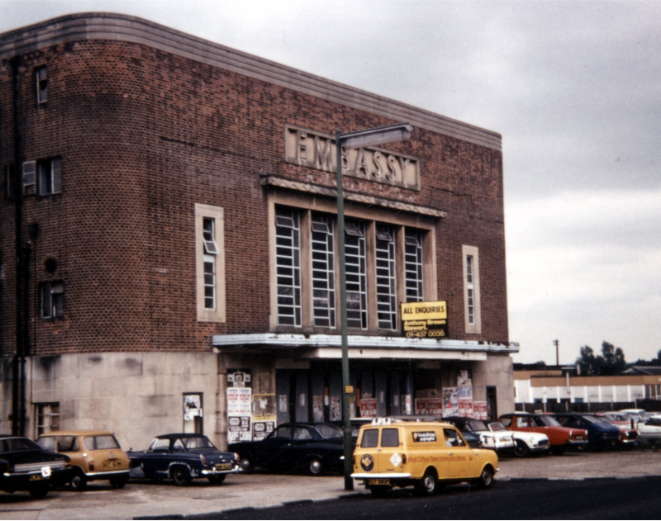
Speaking of houses, Jack’s was a grandiose semi-detached mock-Tudor affair built on Morrell’s Garden Estate in the 1930s, finished in sunflower yellow and black, with a bay window and a distinctive round bathroom window. The roads emphasized the natural curves of the landscape rather than cutting through them. Remember the heavy snows of 1963 ? – Jack was nearly buried (like the cars in the then adjacent Dunstonian Garage) toddling back home with his Dad from the old art deco Embassy Cinema. One-and-a-half cinema tickets were about 4s 7d (23p) for an adult and child – there was always a short film first, then the main feature, and always the National Anthem was played afterwards. The Embassy closed in 1973, eventually to be replaced in 1982 by a Safeway store, promptly causing five local shops (Lipton’s, the Co-Op, Hammett’s and two Express Dairies) to close. Opposite the cinema was a huge ‘Drinka Pinta Milka Day’* advert and it was then no more than 200 yards to walk to Jack’s house in Nightingale Road. Sometimes father and son would divert to G.E. Read (Ironmongers), or Queensway Fisheries to buy chips in newspaper to eat on the way home.

Geoffrey used to balance Jack on his shoulders on the local railway bridge to watch the steam and other trains thunder underneath, including the Brighton Belle. He would encourage him to whistle like the engines. Over the years they watched the coaches’ livery change from Maroon to Green, and eventually to B.R. Blue. Jack dreamt frequently of tumbling out of his father’s arms and falling over that bridge towards the tracks, but despite recurrent nightmares somehow he never hurt himself hitting the ground.

The family favoured self-catering caravan holidays, so between bouncy drives on the back seat of Dad’s green Rootes Hillman Imp, there were many country walks in Devon, Dorset and the Isle of Wight, Jack kicking up the leaves and splashing in any puddles. The pair would record meticulously all the actual distances between driving stops, in the style of the personalised AA Route Plans that Geoffrey would obtain in advance, but to what purpose no-one knows! Rosemary often wore her dated summer candy-striped pink dress for walks, stinging her arms and legs on nettles and carrying a full handbag modelled on the Queen’s famously empty one. Jack’s slight Dad would be encased in his usual sweltering sweater, shirt and weekend tie, carrying a brown sports jacket, picnic hamper and all the largely superfluous bags, not to mention trying to film with his new Picca Super 8 camera. At the seaside he wore a hanky on his head to protect against the sun; and went so far as to roll his trouser legs up and loosen his tie, (as in so many ways) exactly like his own father before him.

Jack once nearly died when the girl next door, Susan, who was five years older than him, panicked the lad she was towing into running in front of a car. Jack was miraculously unhurt, but having reached the other side of the wide thoroughfare, the driver decided to turn round specially so he could drive alongside Jack’s crying and trembling figure as the poor mite walked, so he could swear at him more effectively out of his hand-wound window. Another time Jack was taken to a Zoo, ignoring the animals except to label them as “Big Doggies”. He knew they weren’t, but had not the language then to ascribe to them their proper names. No, Jack engaged in the far more important task of collecting up discarded lolly sticks from the grounds, perchance to throw them in the sealions’ pool !

Jack went every few weeks (under his Mother’s instruction) to his local barber’s, the preposterously-titled ‘Monsieur Frederick’, for a “short back and sides”. Jack timidly walked in, embarrassed to be there at all, and rightly not expecting the sweets given by some such establishments to the young. This very un-French and forbidding man had big heavy guybrows and was the most threatening-looking man Jack had met. He asked most brusquely what was Jack doing there (as the shop was on half-day closing), and lost no time in ejecting him for the heinous crime of wanting a haircut !


Jack’s parents were not so much deep believers in religion, but in tradition, conformity and the gospel of intolerance. Thus they never went to church, but considered forcing him to go to Methodist Sunday School each week was an essential proof of their fervent aspiration to the middle classes. (Jack had secretly given up in belief in God roughly when he’d stopped believing in Father Christmas.) The 5th Petts Wood (Methodist) Cubs (not yet Scouts) in the Lakeswood Hall likewise he tolerated, but the family regarded Baden-Powell & Co. as an essential means of almost Victorian self-improvement, like the superfluous presents of dictionaries, unread thesauruses and ‘Look and Learn’ books that Jack’s paternal Grandad from Beckenham thrust piously upon him.

Rosemary would clean the whole house daily, go fresh food shopping most days, do the washing and ironing, knit a little and maybe stick the almost-worthless Green Shield or Pink trading stamps into their books, then she would prepare the dinner for her husband’s return from the city. Jack’s Mum presented the same food each week in much the same way that “Listen with / Watch with Mother” always presented ‘Andy Pandy’ for example on a Tuesday, and ‘The Woodentops’ on a Friday. There would be a warming-up of the leftovers from Sunday Roast on Monday, mince and mashed potatoes on Tuesday (which enabled Jack to create gravy rivers and mountains in the mash), liver and bacon on Wednesday, and so on.

With his mother as chaperone, visits might be made to grocer Key Markets, or Woolcrafts, such that worn-out socks and stockings would yet again be darned. Jack remembers being in the long-closed Lipton’s and persuading his mother to buy a packet of the “Special Blue Whiteness” (eh? ) that was “OMO”, in the “Giant” (i.e. smallest size)! This, like half-used Angel Delight packets and powdered milk, she kept without using for many years, as she was a hoarder and anyway preferred “Tide”. However Jack’s genius was in the acquisition of the free red plastic Bucket that came with the detergent, which remained in daily use for 25 years!

The evenings Rosemary spent reading about the Royal Family, Winston Churchill or stately homes. Her husband read the Evening Standard on the train home from Martin’s Bank in the City, then, turned his attention to the (then broadsheet not tabloid) ‘Daily Mail’. From this he might have buried himself in the poll statistics when Eric Lubbock of the Liberal Party in 1962 “seized” deeply Conservative Orpington (which included Petts Wood), or studied his startling proposal to build permanent local Gypsy sites**. At 9.00 p.m. Geoffrey would watch the same News on the television, and (most importantly for a Briton) the Weather Forecast – not that rain or repeated assaults on London’s Green Belt stopped him from retreating to his beloved garden.

Rosemary, being a teacher, had excelled at reading fairy tales aloud to her baby son. But having tried sex a few times, she didn’t much like it. Jack’s birth had been difficult, lengthy and painful, and thus she was never going to favour Jack with another brother or sister. While other mothers would compare baby weights and praise their children in a kind of one-upwomanship, she was always complaining to anyone who would listen, principally and ad nauseam to her unfortunate downtrodden husband. She would prefer to be still be doing it today, were he alive. Consequently, she left bath time to Daddy, with a remark such as “Oh, he’s so dirty! ” Sometimes this treat took place in the tin enamel bath with ducks on it in front of the real coal fire, otherwise in the bathroom where the young Jack would splash around and play “sock-racing” by throwing his fetid footwear at his facilitating father. Mummy once held Jack up by his hair, rubbed his seriously soiled pants in his face, and smacked him for the cardinal sin of incontinence. Child abuse by a parent, like paedophilia, was not then considered to be any more feasible than that someone would one day be able to talk to a man on the moon…..


My name is Jane Dee and I’m married to Jack, lugubrious comedian, born in 1961 in Petts Wood. Jeremy Hardy called him “a little ray of sleet” on Radio 4’s “The News Quiz” …..
Telling you all this, Jack will probably suffer now from what he calls “post-disclosure syndrome”, agonising over what I have said about him !

Though I could have told you about Jeremy Forrest, also from Petts Wood, who later on studied at our school ….. as a teacher he recently ran off to France with a girl pupil……
Footnotes:

* ‘Drinka Pinta Milka Day’: In the 1960s parents usually did have doorstep deliveries of 568ml per person per day. Prices remained government controlled until the abolition of the Milk Marketing Board in 1992. Before ‘Margaret Thatcher, Milk Snatcher’, 1960s schoolchildren were allocated a third of a pint bottle at school morning break, for optimum nutrition. In the winter it would sometimes freeze, but Jack preferred this to teachers warming milk up on radiators, as then it usually went rancid.

** Eric Lubbock’s initiative resulted in the Caravan Sites Act 1968.

